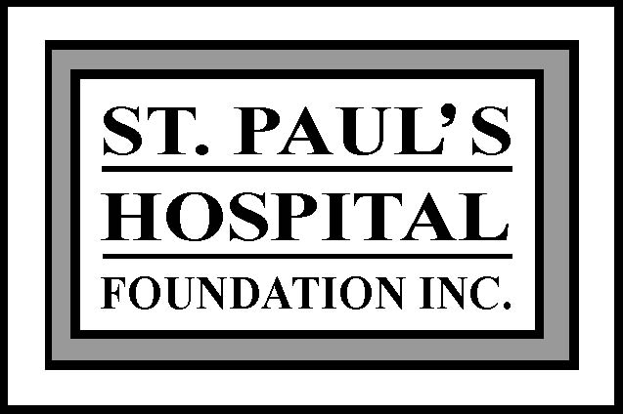
Thank you to our donors for making these awards possible.

SPH Foundation Professional Development Awards

Courses and programs must be consistent with St. Paul’s Hospital’s mission, vision, values & goals

Awards application deadline is September 14th.

Form A

Les Dubé Scholarship
A $2,000 scholarship for a SPH employee enrolled in a health care or allied discipline at a recognized university or post secondary institution. The selection criteria are high scholastic standing, consistent competency in job performance and demonstrated leadership potential. Previous recipients are not eligible.

Janice Bergan Endowment Award
This award assists LPNs taking classes toward certification or classes that will benefit the applicant’s work at St. Paul’s. The award value is determined annually; $1,800 for 2018. Previous recipients are not eligible.

Applicants must include:
- Application form
- Transcripts from previous and/or current post secondary programs
- Current program / class registration information
- Statement of professional goals and objectives and the benefits of this education opportunity
- Recommendation letter from immediate supervisor stating applicant’s work performance and how the education opportunity will benefit SPH and the applicant

Form B

In-Hospital Program Assistance
A grant of up to $6,000 provided to a SPH department or group to assist with organizational costs of setting up in-hospital training and development or other programs.

Urban and Rod Donlevy Innovation Award
A $4,000 grant provided to an individual, department or group within SPH to implement an innovation that will improve Hospital life through operational efficiency, improved patient care, dollar savings and /or the quality of work life for employees. The intention is to support those innovative ideas that otherwise would not be implemented due to limited resources.

Applicants must include:
- Application form – signed by manager
- Statement of program objectives and how they are congruent with SPH’s mission, vision, values and goals; program description with target audience, breakdown of amount requested, organization requirements such as impact on hospital resources and expected outcomes.

Form C
- Ian Buckwold Mental Health and Addictions Continuing Education Award
A $2,000 award provided to an individual, department or group within SHR to provide advanced education or training in the field of Mental Health and Addictions.

Applicants must include:
- Application form - signed by MHA Director
◻ Statement of program objectives and how they are congruent with MHA’s learning goals

Incomplete and late applications will not be considered

Awards may be prorated and allocated to more than one applicant.

The Awards Committee has the option to choose alternate award categories.

Form A St. Paul’s Hospital Foundation Awards Application

Les Dubé Scholarship and Janice Bergan Endowment Award

Name _____________________________ Address ___________________________________________________

City ___________________________________ Postal code ______________________

Home phone _________________ Work phone ________________ Email _________________________________

Current Position ________________________________________________________________ Start Date ___/___/___

Department ____________________________________________________________________________________

❑ Permanent full time  Permanent part time  Temporary full time/part time within SHR for a minimum of 12 months

❑ Applicant works at least 50% of their time at St. Paul’s Hospital

Provide enrollment information from institution you are attending and relevant transcripts from current or previous courses.

Current course registration ____ _______________________________________________________________________

Degree/Certificate sought ___________________ Year to be completed ______________

Total Cost of the Course / Classes / Program (please attach official cost documentation if available):

$__________________________ ◻ see attached

Total Amount requested from SPHF Awards Program (not to exceed award maximum):

$__________________________ ◻ Les Dubé Scholarship ◻ Janice Bergan Endowment Award
◻ I understand that CRA requires the Foundation to issue a T4A. My SIN number is ______________________

Please ensure all required information in this application is complete and accurate.

Applicant signature ________________________________________ Date __________________
Thank you to our donors for making these awards possible.

- Once your application form is complete you must submit it to your immediate supervisor.
- Your immediate supervisor will complete the remainder of the application and submit it to the Foundation office by September 15th for review by the Awards Committee.

Recommendation of immediate supervisor: CONFIDENTIAL

❑ Recommended  Not recommended _______________________________________________________________
Supervisor’s Signature ________________________________________ Date _____________________
Please enclose letter of recommendation as outlined on the information sheet.

Awards Committee Decision:  Approved  Not approved Total awarded $_______________

Signature __________________________________________________________ Date ___________________

Form B St. Paul’s Hospital Foundation Awards Application

In-Hospital Program Assistance and Urban and Rod Donlevy Innovation Award

◻ In-Hospital Program Assistance application on behalf of (dept) ____________________________________________

-OR-

◻ Urban and Rod Donlevy Innovation Award on behalf of (dept or individual) ___________________________________

Applicant Name ______________________________Current Position________________________________________

Work Phone ______________________ Email__________________________________________________

Total Cost of the Program:

$_________________________ ◻ see attached

Total Amount requested from SPHF Awards Program (not to exceed award maximum):

$________________________

◻ Program statement attached including description, objectives, expected outcomes, budget etc.

Please ensure all required information in this application is complete and accurate.

Applicant signature ________________________________________ Date __________________

Thank you to our donors for making these awards possible.

- Once your application form is complete you must submit it to your manager/director.

- Your manager will complete the remainder of the application and submit it to the Foundation office by September 14th for review by the Awards Committee.
____________________________________________________________________________________________________________
Recommendation of Manager: CONFIDENTIAL

❑ Recommended  Not recommended _______________________________________________________________
Manager’s Signature ________________________________________ Date _____________________

Awards Committee Decision:  Approved  Not approved Total awarded $________________

Signature __________________________________________________________ Date ___________________

Form C St. Paul’s Hospital Foundation Awards Application

Ian Buckwold Mental Health and Addictions Continuing Education Award

❑ Application On Behalf of (Dept) ___________________________

OR
❑ Applicant works in the field of mental health and addictions recovery – Department ______________________________
Current Position _________________________Start Date ___/___/___  Permanent full time  Permanent part time

Name _____________________________ Address ___________________________________________________

City ___________________________________ Postal code ______________________

Home phone _________________ Work phone ________________ Email _________________________________

◻ I understand that CRA requires the Foundation to issue a T4A. My SIN number is:_____________________

Provide information regarding the training requested.

Event Type ◻ Conference ◻ Seminar ◻ Workshop ◻ Class

◻ Attach details on how this training fits with the learning goals of MH&A within your department

Date to be completed ___________________

Total Cost of the Course / Classes / Program (please attach official cost documentation if available):

$__________________________ ◻ see attached

Total Amount requested from SPHF Awards Program (not to exceed award maximum of $2,000):

$__________________________

Please ensure all required information in this application is complete and accurate.

Applicant signature ________________________________________ Date __________________
Thank you to our donors for making these awards possible.

- Once your application form is complete you must submit it to your Director.

- Your Director will complete the remainder of the application and submit it to the Foundation office by September 14th for review by the Awards Committee.

Recommendation of Director: CONFIDENTIAL

❑ Recommended  Not recommended _______________________________________________________________
Director’s Signature ________________________________________________ Date _____________________

Awards Committee Decision:  Approved  Not approved Total awarded $________________

Signature ________________________________________________________________ Date ___________________

